ETL, Data Integration, Data Transformation and Data Load Tutorial

This tutorial is in three sections:
- Data Integration (Extract)
- Data Transformation (Quality and Transformations)
- Data Load

We will take two tutorials on it.

Section 1: Data Integration Tutorial

In this tutorial you will plan the data required for the star schema model and design the ETL script.

You have been given two data-bases:
- A spreadsheet (emps_data.xls) detailing the employees and their commission and days sick.

An HR database of employees (oracle database) – a database management system used to manage the employees.

Emps_data.xls employee db
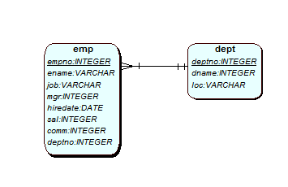
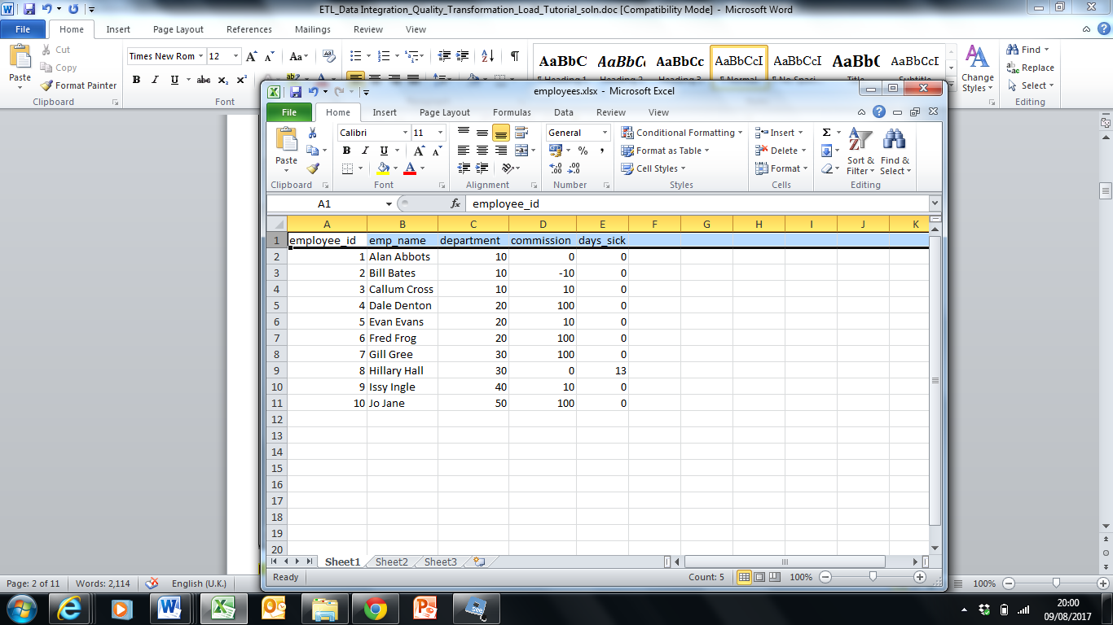

Your role is to integrate these two sources of information by acting as an analyst/ developer on a Data Warehouse (DW) project to support some analysis on the employees.
A DW project has designed the star schema below, to support the reports/investigations.
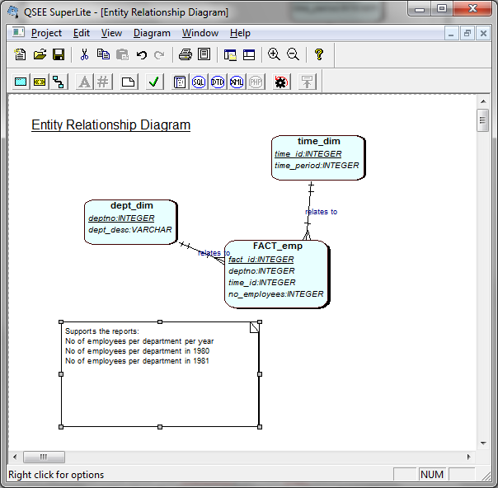

Design and Analysis
Open up Apex and ensure you have tables emp and dept
( CREATE table emp AS SELECT * FROM scott.emp;
CREATE table dept AS SELECT * FROM scott.dept; )

Look at the data in emp and dept, and the data above in the spreadsheet.

Task 1: Understand the data you need
Look at the star schema model and work out the data you will have in each of the tables (dept_dim, time_dim and fact_emp) by integrating the data from the two databases above. You could do this in excel or on a piece of a paper.

The ETL script extracts the data from different sources, deals with any issues between the data sources (transformations) and then loads the ‘clean’ data into the data warehouse (star schema).

Task 2: Design of the ETL script

- Populate the dept_dim

SCOTT.DEPT: DEPTNO AND DNAME
EMPS_DATA: DEPARTMENT

Extracts: List the data you need to select, from where?
Data Quality Checks : What checks could you do on the data?
Data Transformations: Are there differences in the data from the two sources that you have to address?

DATA FROM EMPS_DATA WILL HAVE VALUE FOR ONLY DEPTNO OF 10,20,30,40, AND 50. NO VALUE FOR DEPT_DESC COLUMN IN THE DEPT_DIM.

DATA FROM SCOTT.DEPT WILL HAVE VALUE FOR BOTH DIM COLUMNS I.E. DEPTNO AND DEPT_DESC.

THIS IS HOW WE WILL DIFFERENTIATE VALUES FROM THE TWO DATA SOURCES.

YET – WE HAVE an ISSUE THAT VALUES FOR DEPTNO IN DEPT_DIM ARE THE SAME 10,20,30 AND 40.

PK VALUES MUST BE UNIQUE – SO THIS WILL NOT WORK

OPTION 1 – INTRODUCE A SURRUGOTE KEY
OPTION 2 - “MODIFY” THE PK VALUE TO INCLUDE SOURCE DATA E.G SCOTT_10 AND EMPS_10

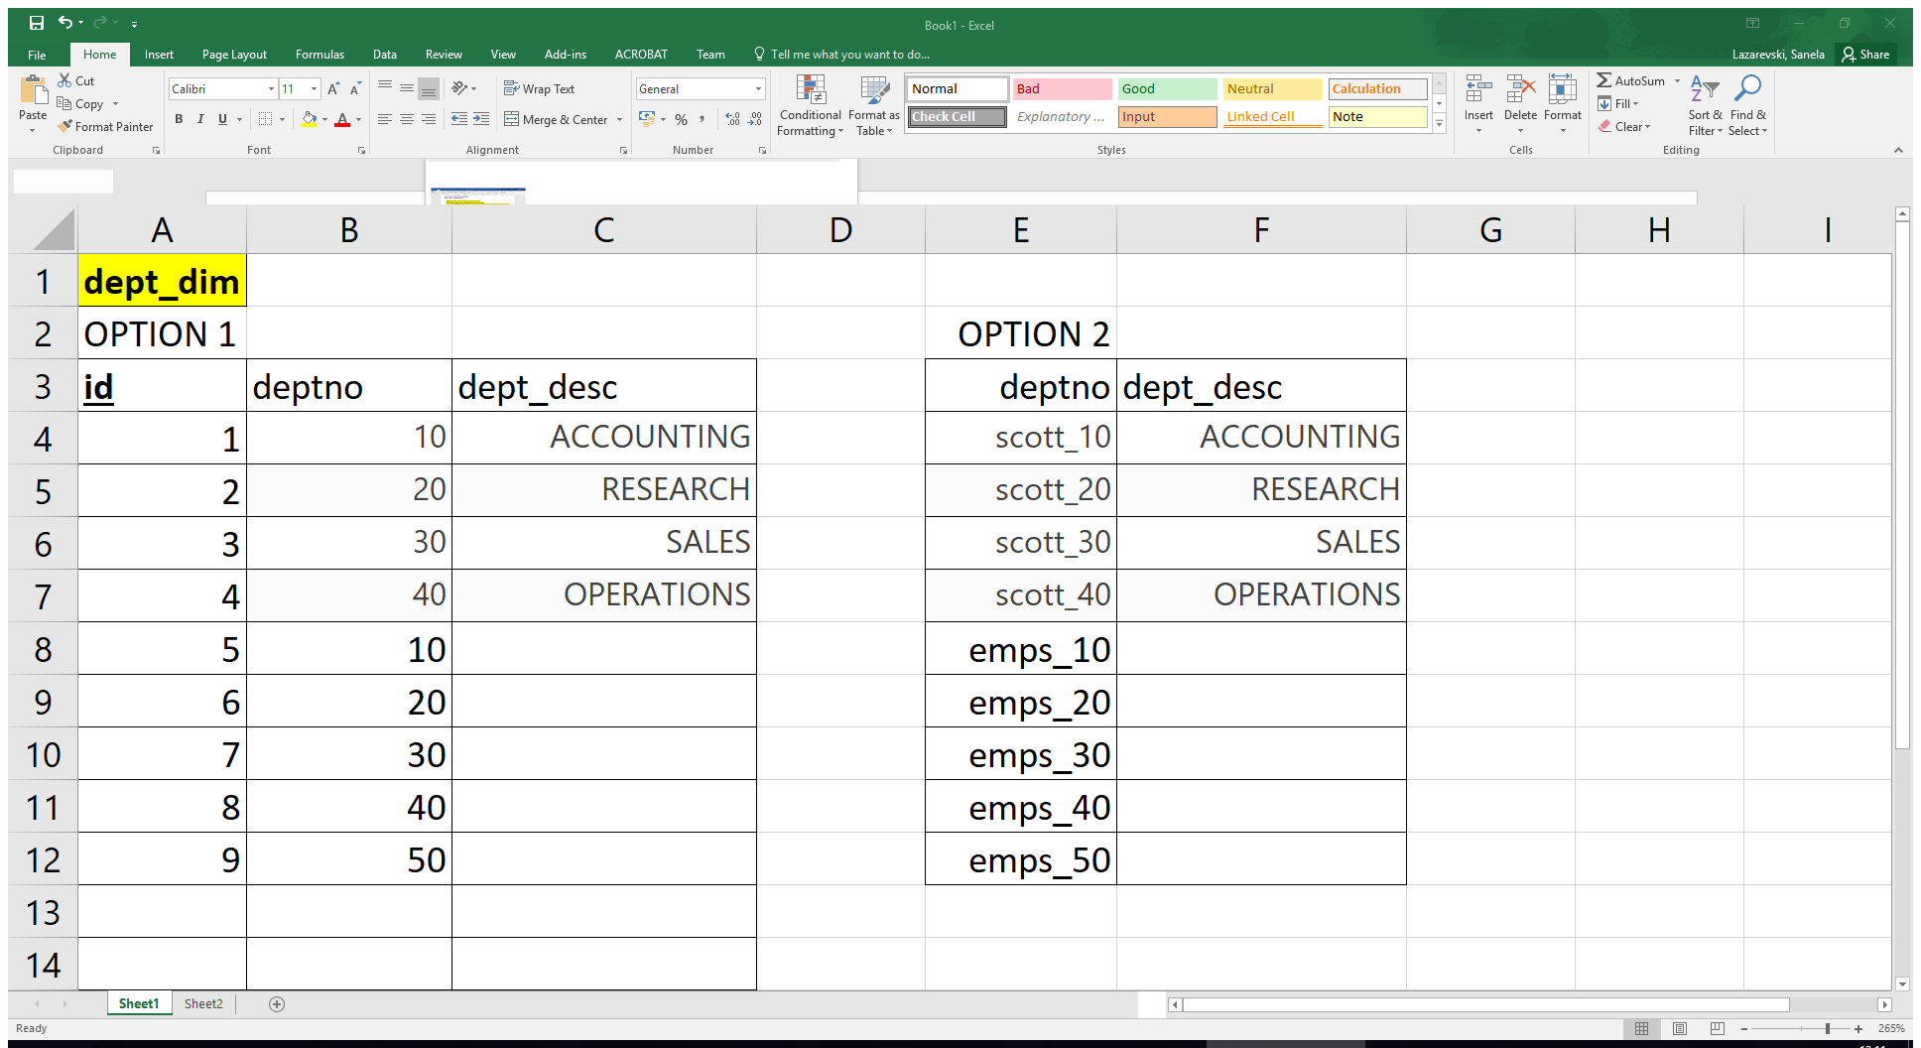

ISSUE WITH OPTION 2 – HOLDING VARCHAR2 values in PK COLUMN. E.G. in Apex, if you want to create an interface, it may not work… apex likes sequence values, i.e. numbers…

- Populate the time_dim
Extracts: List the data you need to select, from where?
Time_DIM – time_id … doesn’t exist therefore you will have to have a surrogate key, populated by a sequence

Insert into dept_dim SELECT deptno and dname from dept table
Insert into dept_dim department FROM emps_dept where department not in dept_dim already

Quality checks – check dept_desc is unique

Time_period will come from hiredate in emp table.
Scott.EMP: hiredate – I would use only date as year. So, you will need to extract year, using EXTRACT function in SQL. Examples given in SQL tutorial week 1.

INSERT in values – 1981, 1982, 1987 ….

Data Quality Checks : What checks could you do on the data?
- The issue is that emps_data does not contain any date data.

Data Transformations: Are there differences in the data from the two sources that you have to address?
- Introduction to the surrogate key
- Extracting the year from the hire data column

- Populate the fact table
How?
- Research into populating fact tables

Two approaches – pay around with the reports GROUP BY.
- Populate all the ids, from the dimension tables and then update the measures from a temporary table.
- Create a tmp_table with the results you want to see in the fact table. Then insert this into the fact table.

Rework this section until you have a design for the ETL script. You may wish to play around in Apex for it.
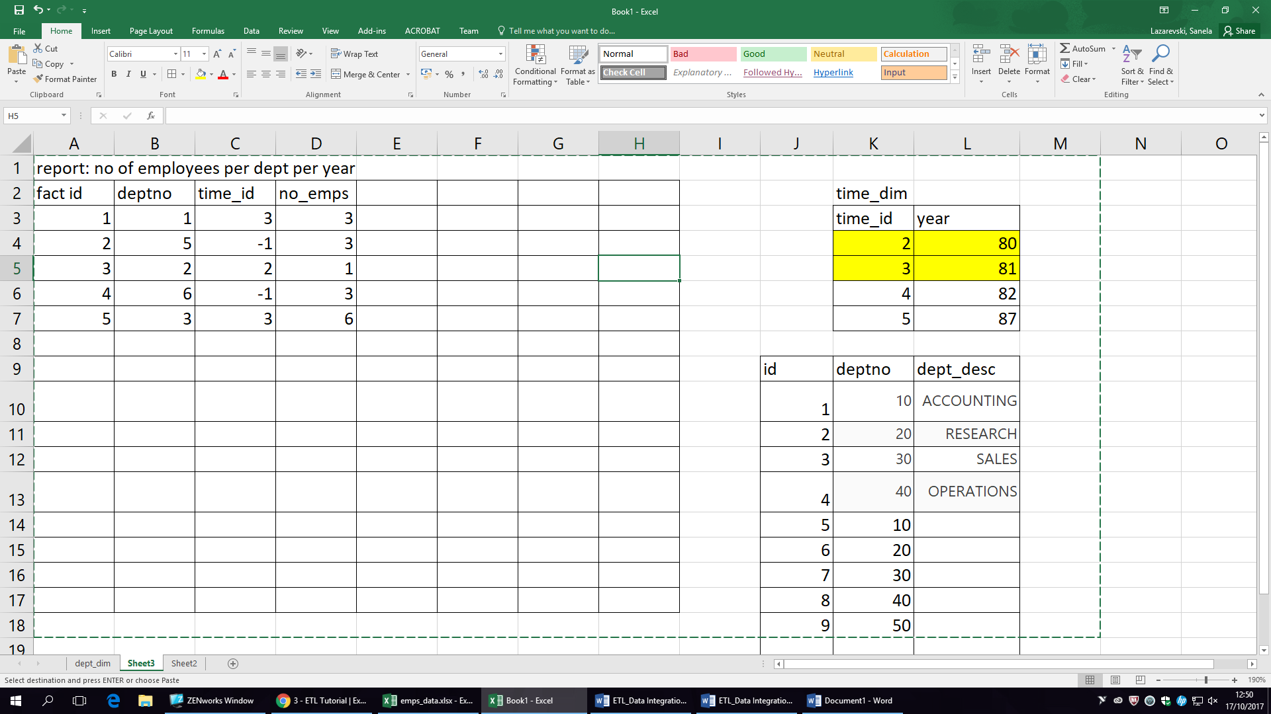

Task 3: Document the star schema model in a Data Dictionary
Create a data dictionary for the star schema above to include the data you have identified as required.
Here is a template/worked example you could use.

Agent_dim
field | data_type | data_source(s) | data_source_type | transformations | quality check
Destination on ss |  | Mappings/Data Source |  | Transformations (quality and issues)
Agent_id | integer | agent_table.a_id | integer | some id's are the same | Check integer  Check unique  Check > 0  Check not null
 |  | agents_spreadsheet.agent_no | integer | increase all ids in spreadsheet by 100
Definition: | This is the unique identifier of the agent, eg ‘11’
Notes: This is the PK, it will be populated via a sequence agent_seq
Agent_name

Task 4: Validate the design
Can you find this out/ answer from your data dictionary?
- How long is a time period?
- Where does the deptno on the department dimension come from?
- Have we ‘lost’ the original ids from any of the dimensions? Is this ok?
- Can we support the report no_of_emps per location? Will fact.deptno ever be null? Is this ok?
- Can we find out the no_of_emps per month?
- What happens if the department changes its name? Will we know this?
- How many rows are expected on the fact table?
- How many new rows will be added to the fact table and how often?
- What indexes are on the fact table?

Add to data dictionary – information of where the original data sources are
Mappings –
And transformations, data quality checks

Section 2: Data Transformation (Quality and transformations)

Data Quality
Task 1: Create a table with some data – to set up the scenario (for data quality and data transformation exercises)

drop table bad_data_emp;
Drop table emp1;
Drop table emp2;

create table bad_data_emp as select * from scott.emp;
Create table emp1 as select * from scott.emp;
Create table emp2 as select * from scott.emp;

**- just adding some data errors :-)
UPDATE bad_data_emp
SET ename = 'smith' WHERE empno = '7369';
UPDATE bad_data_emp
SET ename = 'scott' WHERE empno = '7788';
UPDATE bad_data_emp
SET job = '' WHERE empno IN ('7566', '7844');
UPDATE bad_data_emp
SET empno = '7499' WHERE ename = 'ALLEN';
UPDATE bad_data_emp
SET sal = 15000 WHERE empno = '7698';
UPDATE bad_data_emp
SET hiredate = '02/02/2020' WHERE empno = '7698';

DELETE FROM emp2;

DROP SEQUENCE DI_SEQ;

create sequence DI_SEQ
start with 1
increment by 1
maxvalue 10000
minvalue 1;

-- heres the different data
INSERT INTO emp2(
SELECT DI_SEQ.nextval, ename, job, mgr, hiredate, '20000', '100', 2 FROM emp1 WHERE DEPTNO = '20');
INSERT INTO emp2(
SELECT DI_SEQ.nextval, ename, job, mgr, hiredate,'20000', '100', 3 FROM emp1 WHERE DEPTNO = '30');
INSERT INTO emp2(
SELECT DI_SEQ.nextval, ename, job, mgr, hiredate,'20000', '100', 1 FROM emp1 WHERE DEPTNO = '10');

Now we have three tables: emp1, emp2 and bad_data_emp.
We will do data quality checks on bad_data_emp – and fix them
We will do transformations on emp1 and emp2.

Data Quality
Task 2: Identify the Data Quality Checks
The objective is to find the records with 'bad data'. What is bad data?
From a business perspective – what are the rules?
- each employee must have a job,
- have a salary between 1000 and 10000
- have a hire date before today,
- belong to a department,
- have a job_title,
- have a unique id

So write code to check these 'constraints'
Eg. SELECT * FROM bad_data_emp WHERE job IS NULL;

Data Quality
Task 3: Use code to ‘analyse’ the data and report errors.
Eg. SELECT * FROM bad_data_emp WHERE job IS NULL;

Complete for the rules above in task 2.

Data Quality
Task 4: Log the issues
Create a table to hold/log the issues. The columns of this table are up to you – I have made them fairly generic so that this table can be used for transformations as well ☺ (next !)

drop table data_issues;

CREATE TABLE data_issues
(issue_id NUMBER(2) NOT NULL,
table_name VARCHAR2(20),
row_id NUMBER(4),
data_error_code NUMBER(2),
issue_desc VARCHAR2(50),
issue_date DATE,
issue_status VARCHAR2(20),
status_update_date DATE);

Insert the ‘issues’ into the data_issues table.
Eg:
INSERT INTO data_issues(
SELECT DI_SEQ.nextval,'bad_data_emp', bde.empno, '1', 'NULL DATA-job is NULL',SYSDATE, 'un-fixed', ''
FROM bad_data_emp bde
WHERE bde.job IS NULL);

Data Quality
Task 5: Use code to ‘fix’ the error.
** -- Now can we 'fix' the errors using code
** -- Use database constraints to avoid the problem having occurred in the first place

--Fix the data issues by working through the data_issues table for example
UPDATE bad_data_emp SET job = UPPER('Unknown') WHERE job IS NULL;

And keep a record of what you have done (in the data_issues) table.
UPDATE data_issues SET issue_status = 'job set to Unknown', status_update_date = SYSDATE;
Data Transformations
We are working with emp1 and emp2.

Task 1: Design decisions
-- So we have checked with the Company and deptno 1 equates to deptno10 and 2=20 and 3=30.
-- These are our design decisions
-- First we will update the data, then add the data from emp2 into emp1 - so emp1 holds 'all' the data
-- I am going to log what we do in the data_issues table (from Data Quality tasks above) and use a trigger to do this.

Task 2: Log transformations
- So we want to ‘do’ the transformations and log them to the data_issues table.
- I am going to use a trigger for this.
-- note I am inserting 0 into error code to represent something else

CREATE or REPLACE trigger trg_transform_emp
before update on emp2
for each row
begin
INSERT INTO data_issues
(issue_id, table_name, row_id, data_error_code, issue_desc, issue_date, issue_status, status_update_date)
VALUES
(DI_SEQ.nextval, 'emp2', :OLD.empno, '0', 'transform deptno 1-2-3 to 10-20-30', SYSDATE, 'completed', SYSDATE);
end;

-- run the updates (the transformations)
UPDATE emp2 SET deptno = 10 WHERE deptno = 1;
UPDATE emp2 SET deptno = 20 WHERE deptno = 2;
UPDATE emp2 SET deptno = 30 WHERE deptno = 3;

-- check the data
SELECT * FROM emp2;

-- and check the error log
SELECT * FROM data_issues;

Task 3: Integrate the data
-- now we want hold the data from the data set emp1 and emp2 together in one table - in the emp1 table
INSERT INTO emp1
SELECT * FROM emp2;

-- check
SELECT * FROM emp1;
-- it should have all the data from emp1 and emp2 in it. We could now delete emp2

Task 4: Review the diagram below and note the reports
If we have time create this ERD in QSEE and forward engineer the code.
(the final (edited by JC) scripts for this is at the end)

How to get data into dimensions and FACT tables from the source tables emp1, dept and the employee spreadsheet (remember right back in section1: Data Integration).
The ETL you designed then work should work here.

Let’s just populate the star schema with the data from emp1 and dept.

- Dimensions
Should be fairly straight forward, use INSERT INTO SELECT ???? FROM …;
(Usually) you may need to take the data (using INSERT INTO …) from a few tables.

Your turn: Insert the data into dept_dim from the dept table.
Your turn: Insert the data for 1980 and 1981 into the time_dim table

- FACT table
-- To populate the 'FACT table' eg FACT_emp (FACT_id, deptno, no_employees) where no_employees is the 'measure'
-- first work out the SQL to get number of employers per department

SELECT deptno, COUNT(*) empno FROM emp1 GROUP BY deptno;

-- if you have dates involved eg FACT_emp (FACT_id, deptno, date_id, no_employees) you may need to use a temporary table to help with your calculations - this is all data transformation - occurring in the data staging area.
-- this is just an example

DROP table tmp_emp1;
CREATE TABLE tmp_emp1 AS
SELECT empno, deptno, to_number(to_char(emp1.hiredate,'YYYY')) as which_year FROM emp1;

SELECT which_year, deptno, COUNT(*) no_of_emps FROM tmp_emp1 GROUP by which_year, deptno;

-- now the data from this table can be used to populate the FACT table, using an INSERT INTO and SELECT and a sequence to populate the fact_id.

Your turn: Insert using the data from emp1,dept into FACT_emp
Your turn: Create the report to show (from FACT and dimension tables)
- The number of employees per department per year
- The number of employees per department in 1981

Script to set up Fact and dim tables:
--------------------------------------------------------------
-- Database creation Script
-- Auto-Generated by QSEE-SuperLite (c) 2001-2004 QSEE-Technologies Ltd.
--------------------------------------------------------------
-- Table Creation --
-- Each entity on the model is represented by a table that needs to be created within the Database.
-- Within SQL new tables are created using the CREATE TABLE command.
-- When a table is created its name and its attributes are defined.
-- The values of which are derived from those specified on the model.
-- Certain constraints are sometimes also specified, such as identification of primary keys.
DROP table dept_dim CASCADE CONSTRAINTs;
DROP table time_dim CASCADE CONSTRAINTs;
DROP table fact_emp CASCADE CONSTRAINTs;
-- Create a Database table to represent the "dept_dim" entity.
CREATE TABLE dept_dim(
deptno INTEGER NOT NULL,
dept_desc VARCHAR(10),
Date_effective DATE, -- to support SCD type 3
-- Specify the PRIMARY KEY constraint for table "dept_dim".
-- This indicates which attribute(s) uniquely identify each row of data.
PRIMARY KEY (deptno)
);
-- Create a Database table to represent the "time_dim" entity.
CREATE TABLE time_dim(
time_id INTEGER NOT NULL,
time_period INTEGER,
-- Specify the PRIMARY KEY constraint for table "time_dim".
-- This indicates which attribute(s) uniquely identify each row of data.
PRIMARY KEY (time_id)
);
CREATE TABLE fact_emp(
fact_id INTEGER NOT NULL,
Deptno INTEGER NOT NULL,
time_id INTEGER NOT NULL,
no_employees INTEGER,
PRIMARY KEY (fact_id));
--------------------------------------------------------------
-- Alter Tables to add fk constraints --
-- Now all the tables have been created the ALTER TABLE command is used to define some additional
-- constraints. These typically constrain values of foreign keys to be associated in some way
-- with the primary keys of related tables. Foreign key constraints can actually be specified
-- when each table is created, but doing so can lead to dependency problems within the script
-- i.e. tables may be referenced before they have been created. This method is therefore safer.
-- Alter table to add new constraints required to implement the "relates_to" relationship
-- This constraint ensures that the foreign key of table "FACT_emp"
-- correctly references the primary key of table "dept_dim"
ALTER TABLE FACT_emp ADD CONSTRAINT fk1_FACT_emp_to_dept_dim FOREIGN KEY(deptno) REFERENCES dept_dim(deptno) ;
-- Alter table to add new constraints required to implement the "relates_to" relationship
-- This constraint ensures that the foreign key of table "FACT_emp"
-- correctly references the primary key of table "time_dim"
ALTER TABLE FACT_emp ADD CONSTRAINT fk2_FACT_emp_to_time_dim FOREIGN KEY(time_id) REFERENCES time_dim(time_id) ;
--------------------------------------------------------------
-- End of DDL file auto-generation
--------------------------------------------------------------

